Food Recipe - April 2022 – by Chloe Stevens
This month, I have decided to choose an amazing Easter dessert for the kids and adults who love to make Easter treats. It’s an Easter treat that doesn’t take long to create and is fun if many join in the creating.
I introduce Chocolate Krispy Chick.
Why a Chocolate Krispy Chick?
This is an Easter treat that is Easter themed and complements the traditional Easter Egg.
Ingredients:
For the Chick
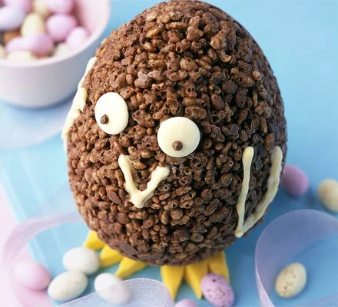
175g milk chocolate, broken into pieces, plus extra for decorating
50g Rice Krispies cereal
To decorate
2 x 50g bags chocolate mini eggs
2 white chocolate buttons
50g golden marzipan
25g white chocolate, broken into pieces,
plus, extra for decorating, melted and cooled a little.
Special equipment
2 chocolate egg moulds, piping bag, rolling pin, flat pastry brush or small paintbrush.

The method follows on the next page

Method:
STEP 1
Break the chocolate into pieces and gently melt in a heatproof bowl over a pan of simmering water: make sure the bowl doesn't touch the water.
Stir until smooth.
Take off the heat and stir in the Rice Krispies, mixing well to coat.
Spoon half the mix into one of the moulds, then use the back of your spoon to press it into a thick, even layer. Be sure to cover the whole of the inside, leaving a thick edge.
Repeat with the other mould.
Leave in a cool place to set.
Put the moulds in the fridge for 5 mins.
TIP: Putting the egg halves in the fridge once the chocolate has set makes it easier to add another layer of warm chocolate. Don’t be tempted to leave the moulds in the fridge any longer than necessary as condensation could cause the chocolate to discolour.

STEP 2
Carefully unmould the eggs.
Fill one half with a few mini eggs.
Fix the halves together with melted chocolate. Patch any holes with a few extra Rice Krispies and melted chocolate.
Leave in a cool place to set.

STEP 3
To make the eyes, paint blobs of melted milk chocolate onto the white chocolate buttons. Fix onto the egg using a little more chocolate.
Spoon the white chocolate into a small piping bag, then pipe a beak and wings onto the egg and allow to set.

STEP 4
For the feet, roll out the marzipan on a sheet of greaseproof paper to about ½ cm thick. Using a knife, cut out two feet, making them large enough for the egg to sit on.
Once the egg has completely set, place the chick on its feet, pressing down so that it stays upright.
Finish by scattering some mini eggs around your chick to create a nest.

